***Report on the Home Automation***

**Contents**

* Acknowledgement
* Abstract
* Introduction
* Concept
* About Project
* Hardware Part
* Circuit Diagrams
* Component Description
* Software Parts

**ABSTRACT**

 The Home Automation is a wireless home automation system that is supposed to be implemented in existing home environments, without any changes in the infrastructure. Home Automation allows the user to control the home from his or her computer and assign actions that should happen depending on time or other sensor readings such as light, temperature or sound from any device in the Home Automation network.

**INTRODUCTION**

This report is describing the project for home automation which was inspired by my father. It is containing the design process of the project starting with introduction to project idea and finishing with the prototype within a house. The original problem was that now a day’s most of the hardware’s come with preinstalled applications and applets. The report is describing what kind of design process, hardware and software have been used to build up the prototype for the product design that I chose as my final goal.

**BACKGROUND**

Home automation is a small step to make one’s home easier to access and control. Home automation started from the late 20th century but the practical application towards the residential sector has not yet gone very far. Only few companies have started it in the private sector though. Residential automation is offered through few service providers but it comes with a huge price tag as well.

**CONCEPT**

Every home automation box is a stand-alone device. It is connected parallel to the existing switches and can control the outlet of electrical devices that is plugged into it. The box will work over the internet so the connectivity of the net should be good as well. The switches can be controlled either by mobile, computer or even a home assistant. People can control power supply of the electrical devices in order to create an interactive home environment to facilitate the control without changing any home appliance. People can enjoy the high technology and simple modern life style. Various different sensors could be attached to the boxes. The sensors are used as triggers for actions, that user can set up in the computer program. For a room there are multiple switches which are connected to different appliances such as lights, fans, televisions, etc. Most of the service providers fail to give manual control back to the user. The above statement can be simplified to that the switch has to be kept on for you to use either your remote or your mobile to switch on/off the appliance. If the switch is manually closed then the remote doesn’t work as well. The home automation box will consist of the motherboard, wiring to the sensors and the relays connecting to the switches.

**ABOUT PROJECT**

Home automation system, or smart home technologies are system and device that can control elements of your home environment such as lights, appliances, fans and also security system. Home automation system ca be operated by electricity or a micro controller or internet, etc. A simple device such as light can be activated by a signal from the motion detector or can be part of the computerized home automation system. As a very basic definition, we tend to refer to home automation as anything that gives you remoter or automatic control of the things around the house.

**DESCRIPTION**

Home automation( also known as domotics) may be designate an emerging practice of increased automation of household appliances and features in residential dwelling, particularly through electronic means that allow for the things impractical, overly expensive or simply impossible in past decades. The term may be used in contrast to the more mainstream “Building Automation” which refers to industrial settings and the automatic or semi-automatic control of lightings, climate doors, windows and security-surveillance systems. The techniques employed in home automation include those building automation as well as the control of home entertainment systems, houseplant watering, etc. Wireless systems are commonly installed when outfitting a pre-existing house, as they obligate the need to make major changes. These communicate via infrared signals, internet and Bluetooth as well with a central controller.

**WHAT CAN HOME AUTOMATION DO?**

Home automation can:

* Increase your independence and give you greater control of your home environment.
* Make it easier to communicate with your family.
* Save you time and effort.
* Improve your personal safety.
* Reduce your heating and cooling costs.
* Increase your home’s energy efficiency.
* Alert you audibly and visually to emergency situations.
* Allow you to monitor your home while you are away.AD

**THE PRIMARY ELEMENTS OF HOME AUTOMATION SYSTEM**

* Operating system such as Arduino, Adafruit, MQTT, BYNK, etc. which will be used for controlling the device.
* Using IFTT, appliances which have their own personal applications can be configured using this to follow a home assistant.
* 2-way switches are required for manual control.
* Each mother box requires a good WiFi connection to stay connected and show real time data in the OS.
* Sensors which will look after various aspects such as CO2 concentration, humidity, temperature, motion, sound, light, etc.
* Micro controller such as ESP8266 development board and raspberry pi 3 boards.

**HOW CAN WE CONTROL THEM?**

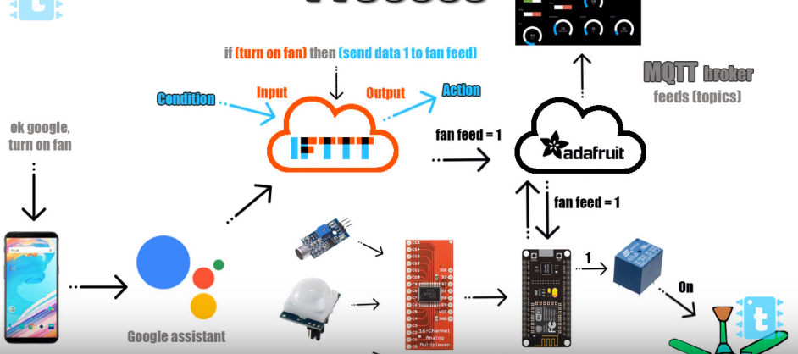

**Remote control**

Remote control gives you the convenience of controlling lighting, appliances, security systems and consumer electronics from wherever you happen to be at the time like your bed or couch. There are several different methods of controlling devices remotely.

**Automatic control**

Automatic control adds convenience by making things happen automatically without any effort being necessary. E.g. have lights turn on automatically on evening and off at the dawn.

**Features**

* Simple, small and handy remote control made up of either of your mobile or your home assistant.
* Micro-controller (NodeMcu Esp8266) based unit for your basic controller as your command box.
* Multi-functional, programmable command unit.
* Application specific programming of micro-controller for industrial purpose and residential purpose as well.
* It’s multi-functional unit so it can be attached to any appliance.
* It can be used to control and operate any application/device remotely.
* It can be used to operate any appliance remotely like fan, bulb, air cooler, table lamp, etc.

**WHY WE USE MICROCONTROLLER?**

It is a multi-channel development board so it can take either up to 8 relays or 4 relays and 5 sensors. You can program it to perform specific task or for specific application. Some applications that I have are remote control appliance using internet.

**HARDWARE PARTS**

* ESP8266 NodeMcu WiFi Development Board:
* CD74HC4067 Analog Digital MUX Breakout Board Module:
* Infrared Pir Motion Sensor Detector Module:
* LDR Light Sensor Module:
* Mq-5 Gas Sensor Module:
* DHT11 Temperature and Humidity Sensor Module:
* Sound Microphone Sensor Detector Module:
* SMPS-9 9V/1A SMPS Adaptor:
* Buzzer:
* BC 547 NPN Amplifier Transistor:
* 330 ohm 1/4w 5% carbon film resistor:
* 7805 Voltage Regulator IC:
* Diode 1N4007:
* SPDT Relay:
* IR Blaster:
* Raspberry pi 3:
* Memory Card:
* USB mic:
* Speaker:
* Multi-port USB input hub:
* IP Camera Wireless Dome Pan/Tilt with 2-Way Audio:

**List of things control by system**

* Lights
* Fans
* Sockets
* A.C.
* Appliances
* Security System

**CIRCUIT AND BLOCK DIAGRAMS**

It is divided into:-

* Main Circuit Diagram
* Components Images
* Connection with the switches
* Main Circuit Diagram

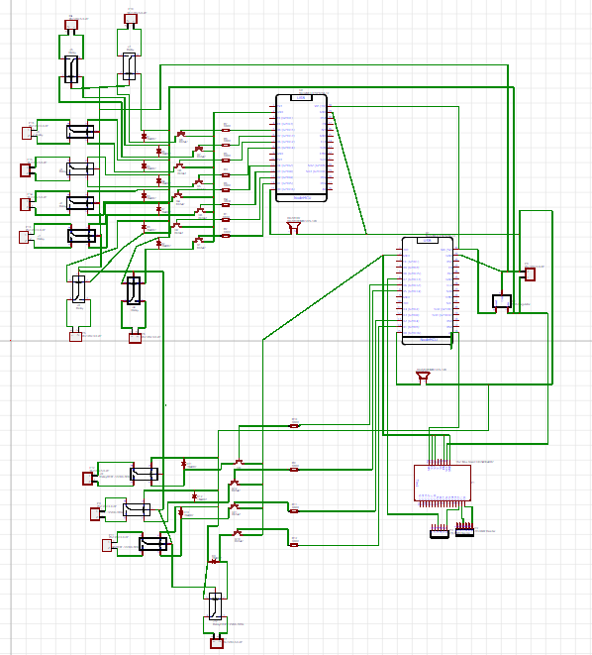

* **Components Images**

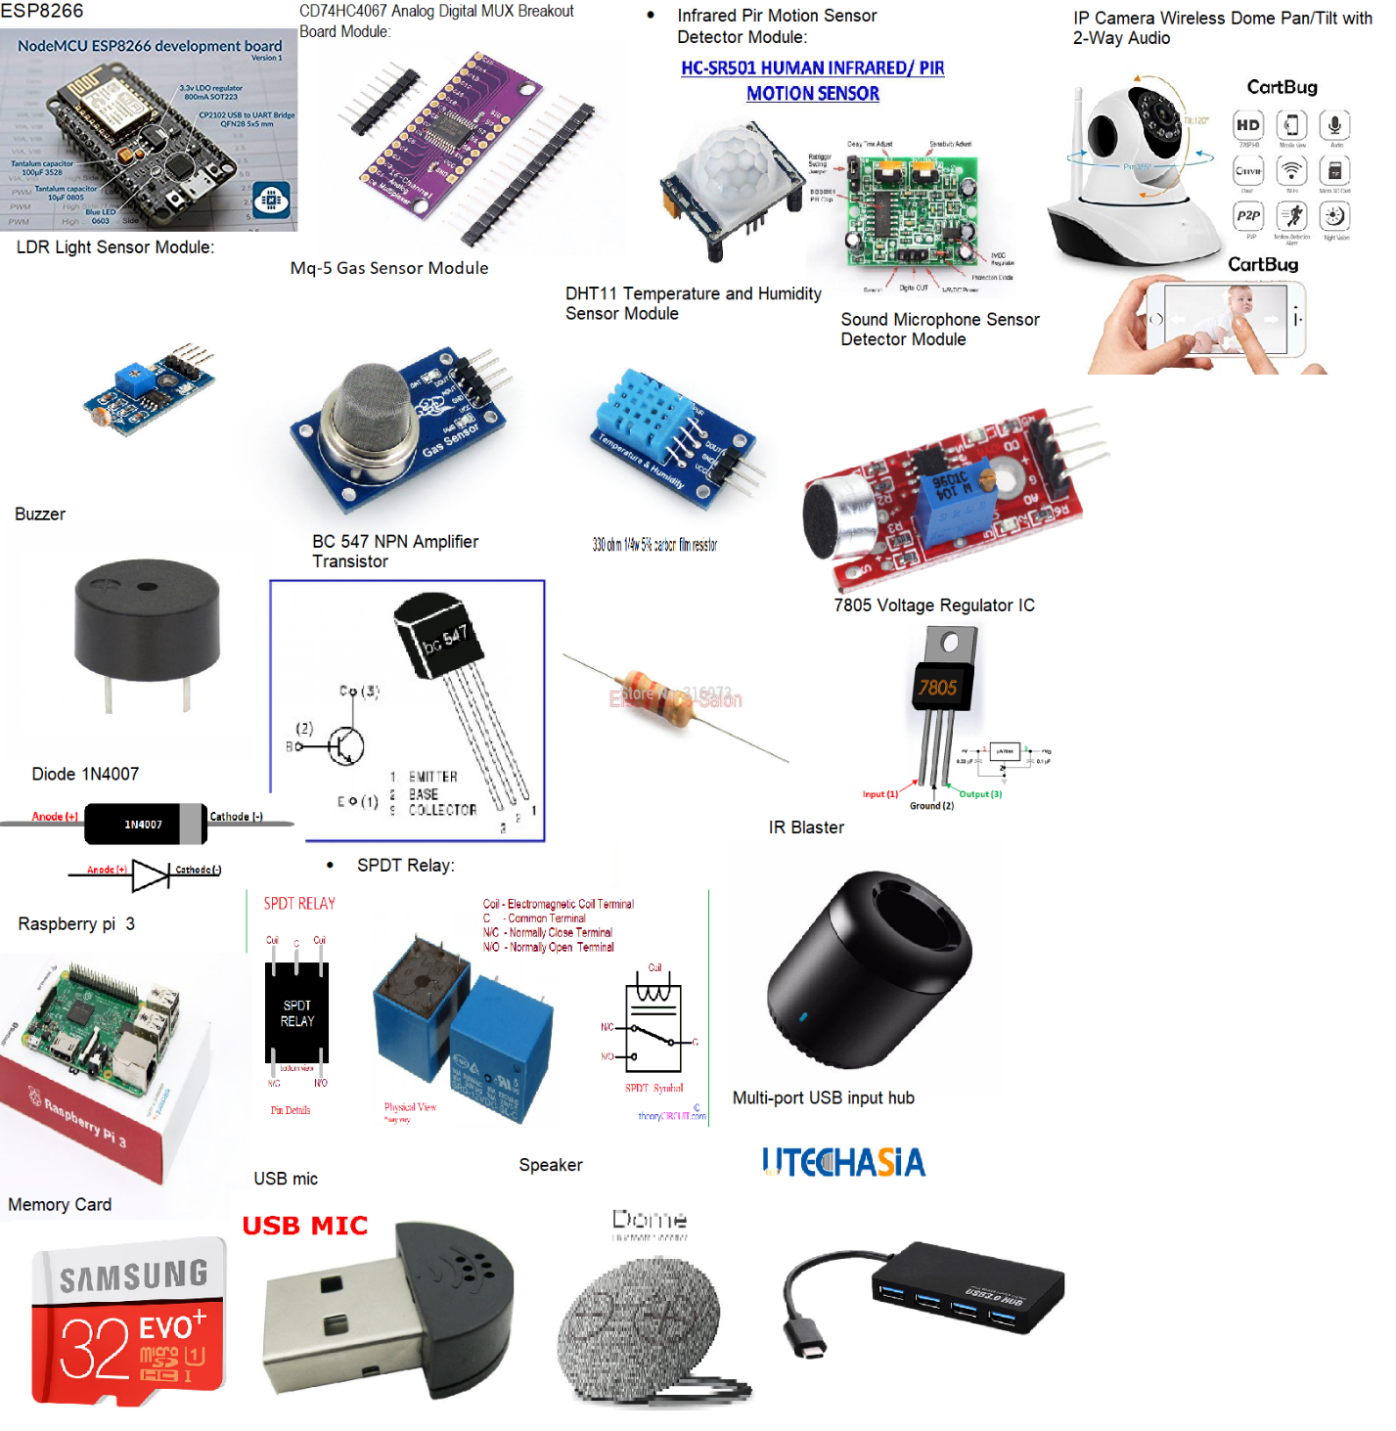

* **Connection with Switches**

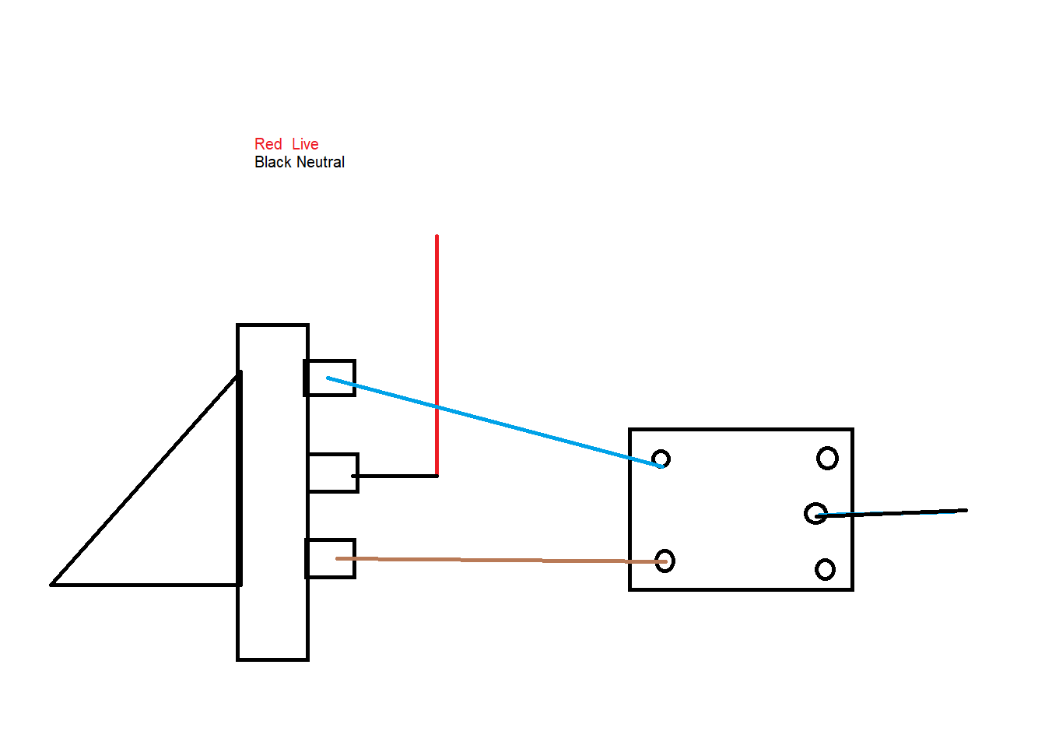

**Components Description**

1. ESP8266 NodeMcu WiFi Development Board: NodeMCU is an open source IoT platform. It includes firmware which runs on the ESP8266 WiFi unit and hardware which is based on the ESP-12 module. This is the micro controller which will connect to the network and work with a variety of layers such as Arduino, MQTT, Blynk, etc. And will receive and send commands to the sensors and relays.
2. CD74HC4067 Analog Digital MUX Breakout Board Module: This is a breakout board for the very handy 16-Channel Analog/Digital Multiplexer/Demultiplexer CD74HC4067. This chip is like a rotary switch - it internally routes the common pin (COM in the schematic, SIG on the board) to one of 16 channel pins. It works with both digital and analog signals (the voltage can’t be higher than VCC), and the connections function in either direction. To control it, connect 4 digital outputs to the chip’s address select pins (S0-S3), and send it the binary address of the channel you want (see the datasheet for details). This allows you to connect up to 16 sensors to your system using only 5 pins. The module is used only to break the signals of 2 inputs from nodemcu to 4 different sensor.
3. Infrared Pir Motion Sensor Detector Module: PIR sensors allow you to sense motion, almost always used to detect whether a human has moved in or out of the sensors range. PIRs are basically made of a pyroelectric sensors (which you can see below as the round metal can with a rectangular crystal in the center), which can detect levels of infrared radiation. Everything emits some low level radiation, and the hotter something is, the more radiation is emitted. The sensor in a motion detector is actually split in two halves. The reason for that is that we are looking to detect motion (change) not average IR levels. The two halves are wired up so that they cancel each other out. If one half sees more or less IR radiation than the other, the output will swing high or low. This is the basic motion sensor which will be used to start the light immediately when you enter the room.
4. LDR Light Sensor Module: The LDR Sensor Module is used to detect the presence of light / measuring the intensity of light. The output of the module goes high in the presence of light and it becomes low in the absence of light. The sensitivity of the signal detection can be adjusted using potentiometer. This will sense and record the intensity of light when it’s on and for how long the light is on.
5. Mq-5 Gas Sensor Module: Gas Sensor (MQ5) module is useful for gas leakage detection (in home and industry). It is suitable for detecting H2, LPG, CH4, CO, Alcohol. Due to its high sensitivity and fast response time, measurements can be taken as soon as possible. The sensitivity of the sensor can be adjusted by using the potentiometer. This module which will record the CO2 concentration in a room.
6. DHT11 Temperature and Humidity Sensor Module: DHT11 digital temperature and humidity sensor is a composite Sensor contains a calibrated digital signal output of the temperature and humidity. Application of a dedicated digital modules collection technology and the temperature and humidity sensing technology, to ensure that the product has high reliability and excellent long-term stability. It will record the Humidity and Temperature of the room.
7. Sound Microphone Sensor Detector Module: The sound sensor module provides an easy way to detect sound and is generally used for detecting sound intensity. This module can be used for security, switch, and monitoring applications. Its accuracy can be easily adjusted for the convenience of usage. It uses a microphone which supplies the input to an amplifier, peak detector and buffer. When the sensor detects a sound, it processes an output signal voltage which is sent to a microcontroller then performs necessary processing. This is used as a security system to sense any sound disturbance in a room.
8. SMPS-9 9V/1A SMPS Adaptor: switched mode power supply (smps) is advance power supply and batter then conventional ones. If you want low losses and stable output also you don't want to make a rectifier, so go for smps. It converts the 230V AC to 5V DC as the power supply for the microcontroller.
9. Buzzer: A piezoelectric element may be driven by an oscillating electronic circuit or other audio signal source, driven with a piezoelectric audio amplifier. Sounds commonly used to indicate that a button has been pressed are a click, a ring or a beep. It is used to just let us know the system is online and gives us respond.
10. BC 547 NPN Amplifier Transistor: BC547 is an NPN bi-polar junction transistor. A transistor, stands for transfer of resistance, is commonly used to amplify current. A small current at its base controls a larger current at collector & emitter terminals.BC547 is mainly used for amplification and switching purposes. It has a maximum current gain of 800. Its equivalent transistors are BC548 and BC549.The transistor terminals require a fixed DC voltage to operate in the desired region of its characteristic curves. This is known as the biasing. For amplification applications, the transistor is biased such that it is partly on for all input conditions. The input signal at base is amplified and taken at the emitter. BC547 is used in common emitter configuration for amplifiers. The voltage divider is the commonly used biasing mode. For switching applications, transistor is biased so that it remains fully on if there is a signal at its base. In the absence of base signal, it gets completely off. It is used as a switch to shift the micro controller signal from one end of relay.
11. 330 ohm 1/4w 5% carbon film resistor: A resistor is a passive 2 terminal electrical component that implements electrical resistance as a circuit element. In electronic circuits, resistors are used to reduce current flow, adjust signal levels, to divide voltages, bias active elements, and terminate transmission lines, among other uses. Modulate the signal flow from one end of micro controller to the transistor so that the transistor can act as a switch.
12. 7805 Voltage Regulator IC: **7805** is a**voltage regulator**integrated circuit. It is a member of 78xx series of fixed linear voltage regulator ICs. The voltage source in a circuit may have fluctuations and would not give the fixed voltage output. The **voltage regulator IC** maintains the output voltage at a constant value. The xx in 78xx indicates the fixed output voltage it is designed to provide. 7805 provides +5V regulated power supply. Capacitors of suitable values can be connected at input and output pins depending upon the respective voltage levels. This is majorly used to regulate the current from the SMPS to step down to another 5V DC.
13. Diode 1N4007: 1N4007 is a member of 1N400x diodes. Diode is a rectifying device which conducts only from anode to cathode. Diode behaves open circuited for the current flow from cathode to anode. 1N4007 is a 7A diode with low forward voltage drop and high surge current capability. It comprises of diffused PN junction and has low reverse leakage current of 5µA. Its DC blocking voltage is 50V.The cathode (n) is identified by a bar on diode case. The other terminal is the anode (p).
14. SPDT Relay: A **relay** is an electrically operated switch. Many relays use an electromagnet to mechanically operate a switch, but other operating principles are also used, such as solid-state relay. Relays are used where it is necessary to control a circuit by a separate low-power signal, or where several circuits must be controlled by one signal. The first relays were used in long distance telegraph circuits as amplifiers: they repeated the signal coming in from one circuit and re-transmitted it on another circuit. Relays were used extensively in telephone exchanges and early computers to perform logical operations. Single pole, double throw, a simple type of changeover electrical switch.
15. IR Blaster: The device can be controlled and configured using Broadlink e-Control app for Android 4.0 or above. You’ll be able to select a remote from a list of device or make the device learn your appliances’ remote control, and then control the said appliances via your smartphone manually or through timers. There’s also a function for “healthy sleeping” that automatically adjust your aircon temperature at night, and devices can be controlled from anywhere as long as you have an Internet connection.
16. Raspberry pi 3: The Raspberry Pi is a series of small single-board computers developed in the UK by the Raspberry Pi Foundation to promote the teaching of basic computer science in schools. It does not include peripherals (such as keyboards, mice and cases). Raspberry pie is a portable, powerful and minicomputer. The board length is only 85mm and width is only 56mm.Its size only as big as a credit card but it is a capable little PC. It can be used for many of the things that your desktop PC does, like high-definition video, spreadsheets, word-processing, games and more. Raspberry Pi also has more wide application range, such as music machines, parent detectors to weather stations, tweeting birdhouses with infra-red cameras, lightweight web server, home automation server, etc. It enables people of all ages to explore computing, learn to program and understand how computers work. The Raspberry Pi Model B+ provides more GPIO, more USB than Model B. It also improves power consumption, audio circuit and SD card. It is more useful for embedded projects.
17. Memory Card: It is an electronic flash memory data storage device used for storing digital information. These are commonly used in portable electronic devices, such as digital cameras, laptops, mobile phones, computers, tablets, etc.
18. USB mic: It is a transducer that converts sound into an electrical signal. It will enhance the soundwaves for the raspberry to acknowledge the input.
19. Speaker: **Wireless speakers** are loudspeakers which receive audio signals using radio frequency (RF) waves rather than over audio cables. The two most popular RF frequencies that support audio transmission to wireless loudspeakers include a variation of WiFi IEEE 802.11 while others depend on Bluetooth to transmit audio data to the receiving speaker. Wireless speakers are composed of two units: a main speaker unit combining the loudspeaker itself with an RF receiver, and an RF transmitter unit. The transmitter connects to the audio output of any audio devices such as hi-fi equipment, televisions, computers, mp3 players, etc. An RCA plug is normally used to achieve this. The receiver is positioned where the listener wants the sound to be, providing the freedom to move the wireless speakers around without the need of using cables. The receiver/speaker unit generally contains an amplifier to boost the audio signal to the loudspeaker; it is powered either by batteries or by an AC electric outlet. Batteries may last for 3 to as long as 24 hours; almost all wireless speakers operate on rechargeable batteries that are not replaceable, so that the lifespan of these speakers is that of their batteries.
20. Multi-port USB input hub: High speed USB 2.0 4 port hub can transfer large files at a high speed of up to 480 Mbps. Its miniature circuit design makes it highly portable, yet it can be used in desktops with an extension cable provided with the hub.
21. IP Camera Wireless Dome Pan/Tilt with 2-Way Audio:  HD Pan & Tilt Smart Wireless WiFi IP Camera is a simple to use a camera that can be conveniently positioned within the home (within wireless range of your internet router) and remotely controlled from your Smartphone, tablet or computer. You can also use it without any Wi-Fi connection, using AP mode. It features crystal clear picture quality, capturing video in HD 720P at 30 frame per second, includes Pan & Tilt (Left, Right, 355 degree; Up, Down, 60 degree), a built-in microphone and speaker to allow you to listen and speak back to where the camera is located, a memory card socket to capture video 24/7 onto a memory card (up to 128GB, not included) and a wealth of other great features. If you want a simple surveillance product to protect your home or a discreet way to monitor (and listen/speak to) children, elderly relatives or pets wherever you are in the world, then this is the ideal product for you. The built-in ultra-responsive microphone allows you to have smooth stable conversations through the Mobile App, wherever you want. Intercom mode lets you activate the microphone and speaker, so you can send commands to your pet, or scare off unwanted guests. The hands-free mode allows for a flexible two-way conversation with your loved ones. Night vision provides you the clear image even in the dark. The powerful and efficient infrared night vision can reach up to 16 feet irradiation distance and it's clearly visible during the night. You can monitor your house at night. It also features an intelligent system to ensure clear and high-quality images day and night. Easy to set up and operate. No need of installation service *Just plug into the power source and your Home and Office live view is always there on your mobile/Tablet *Cloud Recording, save images on FTP server. Keep recordings safe on cloud server even if the camera is stolen or broken.

***Software Parts***

OS used are Arduino and raspberry pi operating system (commonly known as raspberian).

The system starts and the buzzer will start to show if the board has connected to the WiFi. Using Adafruit, IFTT, MQTT, BYNK the client (user) sends a request to the server and the server sends the request to the board and then the board changes the relays.